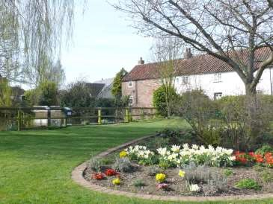

The Newsletter for Middleton on the Wolds

Issue No 13

March 2020

This issue is sponsored by Soanes Poultry

NEXT COPY DATE

14th March

Please send in your contributions to middletonflyer@yahoo.com. If I don’t acknowledge them please get in touch to make sure they have arrived.

We are grateful to Soanes Poultry who have given a donation towards the production of this issue of The Messenger.

Lyn

4
The Paddocks
219500

CHARITY COFFEE MORNINGS

will be held in the Reading Rooms on

Saturday 21st March

from 10.00am

All are welcome for tea/coffee and teacake

plus a raffle in aid of

Parkinsons

VILLAGE LUNCH
THE ROBIN HOOD INN
Monday 2nd March
12.15 for 12.30pm
If regulars are unable to attend please contact Lynn Wooldridge on 217457 by Friday 28th February. Anyone wishing to come for the first time is most welcome and should contact Lynn to book a meal.

editorial
Well, what a to-do over the embankment! There have been a lot of recriminations flying around over the felling, and delays to the felling, of trees overlooking Greenfield Road backing on to the embankment. It seems that some people wanted to stop the indiscriminate clearing of the embankment (a Good Thing) whereas the priority for others was making sure that their property
wasn’t in danger of falling trees (also a Good Thing). It looks like the problem was a lack of communication between concerned parties and, as the work is now going ahead (in a more environmentally sympathetic way) we can put it all behind us.
On to more mundane issues and I would appreciate it if you could let me know about what you want for the village’s VE day celebrations if, indeed, you want to do anything at all. Given that the anniversary is in May we really need to get moving.
Finally, and on an unashamedly personal note, if anyone knows who turned a tractor round in my front garden on Wednesday 5th February could you let them know that they churned-up part of the drive. Or they could just apologise – you know where to find me.
Cheers,
Mike
If you have any ideas, comments or complaints (especially complaints) you want to share then send an email to middletonflyer@yahoo.com.
ADVERTISING COSTS for the Messenger

Rates Month Year

Whole Page £25 £150

1/2 Page £15 £100
1/3 Page £10 £60

Full colour - Print run 500 copies

Contact: Tina 01377 217242, middletonflyer@yahoo.com

A note from your vicar
This year Shrove Tuesday falls on the 25th February. In Britain it is more popularly known as ‘pancake day’. When the Lenten Fast was more strictly kept all rich foods including meat, eggs and cream had to be eaten before the season of Lent began on Ash Wednesday. In other countries it is Carnival time, the word ‘Carnival’ comes from two Latin words – ‘Carni’ which means ‘meat’ and ‘Val’ which means ‘good buy’. So literally ‘Carnival’ means ‘good buy to meat’. Part of the message of Carnival is that the fun cannot last, it has to stop when Lent begins.
Shrovetide is about the forgiveness of sins. The old English word ‘shrive’ means to pronounce absolution. In pre-reformation England people would actually queue up outside of church to go to confession and so be ‘shriven’ as Lent began. A bell would be rung to call the faithful to the service and, over time, in some areas it became known as the ‘pancake bell’.
In Olney, Buckinghamshire one year a woman was in such a hurry to get to church on Shrove Tuesday on hearing the ‘pancake bell’ that she ran out of the house still clutching the frying pan. Now, every year the women of the village dress in aprons and head scarves and have a pancake race up the main road from the pub to the church. They have to carry a frying pan and toss a pancake three times without dropping it (as a symbol of the Trinity) The first lady to reach the church may claim her prize.
Men have also been involved in Shrovetide traditions, often associated with street football although many have been banned as they often resulted in fighting, serious injury and even death. However, one still exists in Ashbourne in Derbyshire. The teams are made up of residents from the north side of Henmore Brook – the ‘Upwards’ and the south side – the
‘Down’ards’. The goals, originally two mills, lie 1 ½ miles either side of the brook – so the pitch is 3 miles long! If there is no score by 10pm on Shrove Tuesday play is suspended until Ash Wednesday.
The pancake race sounds like a much safer option!
Rev Jane

The wolds METHODIST CHURCH bainton
Services for March
Sunday 1st 10.30am | Service at the Wolds Methodist Church,
 | Miss Margaret Collinson
Sunday 8th 10.45am | United service at St Andrew’s Church Middleton
Sunday 15th 10.30am | Service at the Wolds Methodist Church,
 | Mr Andrew Barraclough
Sunday 22nd 10.30am | Mothering Sunday Service at the Wolds Methodist
 | Church, Mr Peter Rogers
Sunday 29th 10.30am | Service at Wetwang Methodist Church, Holy
 | Communion, Rev Robert Amos
Sunday 29th 6.00pm Songs of Praise in the Reading Rooms
St Andrew’S church
Services for March
Sunday 1st No service at Middleton
Sunday 8th 10.45am Joint worship/Holy Communion, Rev Jane
Anderson
Sunday 15th 10.00am Benefice Holy communion, meet the visiting
Bishop
Sunday 22nd 10.30am Holy Communion, Rev Ruth Newton
Sunday 29th 10.00am Benefice Holy Communion at Bainton
Sunday 29th 6.00pm Songs of Praise in the Reading Rooms
SONGS OF PRAISE
Songs of Praise will resume after the winter break on Sunday 29th March at 6.0pm in the Reading Rooms.
We meet at the same time, same place as above on the last Sunday of each month and anyone who enjoys singing hymns will be very welcome to join us.

OBITUARY: MR RONALD TOWSE

On 20th January 2020 a meaningful service took place at the Octon Crematorium to celebrate the life of “Ron” Towse – a special and well known resident of Middleton on the Wolds. He sadly died on 19th December 2019 aged 88 years after a long period of illness during which time he displayed remarkable courage. He lived with his dear and beloved wife Eileen for 62 years and many people remember him for his passion, pride and expertise for gardening, a significant talent reflected in his own and many other gardens he tended. We shall also remember him as a quiet, gentle, caring, generous and committed gentleman who treasured his family enormously.
He will be sorely missed by his dear family and many friends.
Holderness Area Rural Transport is the project name of North Holderness Community Transport. Five rural villages came together in 2003 to tackle transport need in Holderness. With a grant from the Countryside Agency the first vehicle was purchased to operate transport to health care facilities.
Today the charity has 9 vehicles covering the East Riding of Yorkshire coast from Bempton to Spurn including the market towns of Driffield, Hedon, Withernsea and Hornsea.
The charity exists due to the tremendous effort of volunteers including the board of trustees, minibus and car drivers, and office workers. We welcome and value the work of volunteers, if you would like to get involved we would love to hear from you.
NORTH HOLDERNESS COMMUNITY TRANSPORT H.A.R.T. YARD
CLIFF ROAD
HORNSEA
HU18 1JB
01964 536684 hart@medibus.org.uk

DEFIBRILLATOR TRAINING
Community AED units are easy to use life-saving devices.
An AED is a computerised device that is designed to deliver a shock to a patient and bring a person’s heart back to a normal beating rhythm following a cardiac arrest. It is important to deliver the shock as soon as possible, using an AED in the minutes before an ambulance arrives can double someone’s chances of survival.
Would you know what do and how to use the equipment?

Come along to the Reading Rooms
on Thursday 5th March 2020 at 7.30pm
Session will last approx. 1 hr

This training will build your confidence to know exactly what to do in an emergency.
Contact Sandra on 01262 470496 or Kath 01377 217456
MIDDLETON & NORTH DALTON CRICKET CLUB
We will once again be having
Saturday 2 Teams
Wednesday Evening 1 Team - York League
Thursday Evening 2 Teams - Bridlington Evening League

The Club will be holding pre-season nets at The Old Railway Station Pocklington on the following Sundays in March:
8th, 15th, 22nd & 29th 2.30 - 3.30pm
As a Club we are always looking to recruit players so if you’re new to the village and are interested contacts are:
Dave Brent 07788985745
Ricky Woodmansey 07975519807
Dave Newlove 07901833784
Alternatively you can search for us on Facebook

Reading rooms
The Reading Rooms are looking for committee members, especially a secretary. Ideally the committee will eventually be made up of representatives of users so, if you want to get involved please contact Mike Kelly on 0771 362 0912.
If anyone has any ideas on how we could use the Reading Rooms please let us know. In the meantime I hope lots of you will come to the Games Night on the 18th (see the ad for details).

Games Night at
The Reading Rooms
Wednesday March 18th
7PM to 10PM
Admission £2.
All welcome
Board games, cards, dominoes, chess – or whatever you want to bring along for an evening of fun and making friends.
Bring a bottle and make the evening even more fun!

Parish council news
Many of you will have noticed that Tree Surgeons have been felling trees from along the old railway line. This work has been organised and paid for by the East Riding of Yorkshire Council and Middleton Parish Council were not informed that the works were to be carried out.
Fortunately, several members of the Parish Council and Mr Andrew Naylor of Middleton Womblers managed to intervene in the tree surgeons early works and with the help of our Ward Councillor Kevin Beaumont and put a stop to their plans to totally clear the embankment. The plan was to form a wide enough track for a tractor and trailer to be able to access the full length of the railway line.
We have had many concerned residents enquiring what was going on and who had organised this. And many did not agree with removing trees and overgrowth, destroying a natural habit for wildlife. The trees along the bank of the railway line have however been removed as many of them are Ash trees which are or will become infected and a number of residents on Greenfield Road had complained that the trees which are adjacent to their gardens are unsafe and would cause considerable damage if they were to be blown over in stormy / windy weather.
I am sure there are many mixed views with some people still having very strong feelings, and object to the work being done; we must remember the whole of the railway line belongs to the East Riding of Yorkshire Council. The felling of the trees has also safeguarded the properties on Greenfield Road and residents can safely enjoy their gardens without the fear of falling trees / branches.
Let’s all hope the railway line recovers and, with the addition of new trees that have been planted, we can all continue to enjoy our lovely walks along the railway line.
Thanks to all those who helped in restricting the works.
John Eastwood Chaiman

My duties as clerk to the Parish are wide and varied. Whilst I am accountable to the Council, managing its affairs and ensuring the lawful running of Council business, I am also accountable to the residents of the Parish as I am often the first port of call for complaints.
There have been several issues that have been brought to my attention over the past few weeks;
- The disused railway embankment and the felling of the ash trees overhanging onto Greenfield Road. - Whilst the embankment is largely maintained by the Parish Council as a nature trail and footpath it is actually owned by the local authority, and East Riding have instigated the felling of the trees. Once this was brought to our attention, we have been working with both ER and the contractors endeavouring to ensure that as little damage as possible is done to this much loved area whilst this essential work is going on.
- Off street parking along Station Road and Pickering Park and the change of pickup and collection for the Driffield School bus. - Again this matter is being dealt with and we are liaising with ER to hopefully improve the situation.
- Damaged grass verges. - At this time of the year the grass verges are very soft, and drivers are causing damage to the verges by either parking on them, or driving on them to avoid other vehicles.
We all want to live in an area that is attractive and well maintained. The Parish Council is here to help, within the boundaries of our remit. We can do many things, but all must be within our limited powers. We will help where we can, and always listen to your issues.
Your Council meets on the first Monday of the month (except Bank holidays and the month of August) at the Reading Rooms on Front Street. Meetings are open to members of the public. If you wish to address the Council at a meeting please let me know. If you wish to raise a point of issue with the council, again let me know and I will take the appropriate action. If the issue in question is a local authority matter, these should be reported to the East Riding of Yorkshire Council, through their own reporting system either on line, or by telephone.
Sandra Morrison Clerk to the Parish

Village hall news
You can hire the Village Hall for only £8 per hour or at a reduced rate of £28 for 4 hours and £50 for a day. To enquire please ring Lyn on 219500 or email lyndennis456@gmail.com.
A future date for your diaries - July 11th -
when the Driffield Middle 8 Singers will be performing songs from the 60s and 70s. More details later.
Opposite is a poster for our Easter Fair which will be on Saturday 4th April (don’t forget to get in touch with Sharon if you would like to reserve a table for your crafts). Soanes Poultry are very generously sponsoring this event to help us raise money towards the roof repairs.

QUIZ PAGE
- What is the biggest island in the world?
- The Little Mermaid is based on a story by which 19th century writer?
- Which city is the only city in the world to span two continents?
- In which year was the summit of Mount Everest first reached?
- It's a flock of sheep what's a group of owls called?
- What was the first hospital TV drama?
- Who said "Hello, good evening, and welcome"?
- Who was called The Man of Destiny?
- What was the cause of George Harrison's Death
- Richard Wagner was the father of which other famous composer?
Quiz set by Rowland Wooldridge
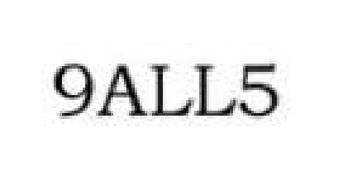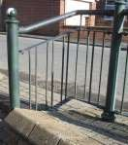

GENERAL DINGBATS

SUDOKU

WHERE IN MIDDLETON?

2

9

6

7

7

4

2

5

9

8

4

1

6

5

7

2

5

1

6

5

4

3

8

4

7

6

1

9

7

6

3

9

Photos by Ian Lavender All answers on page 33
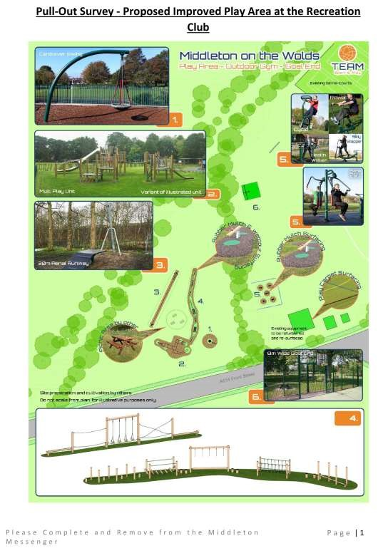

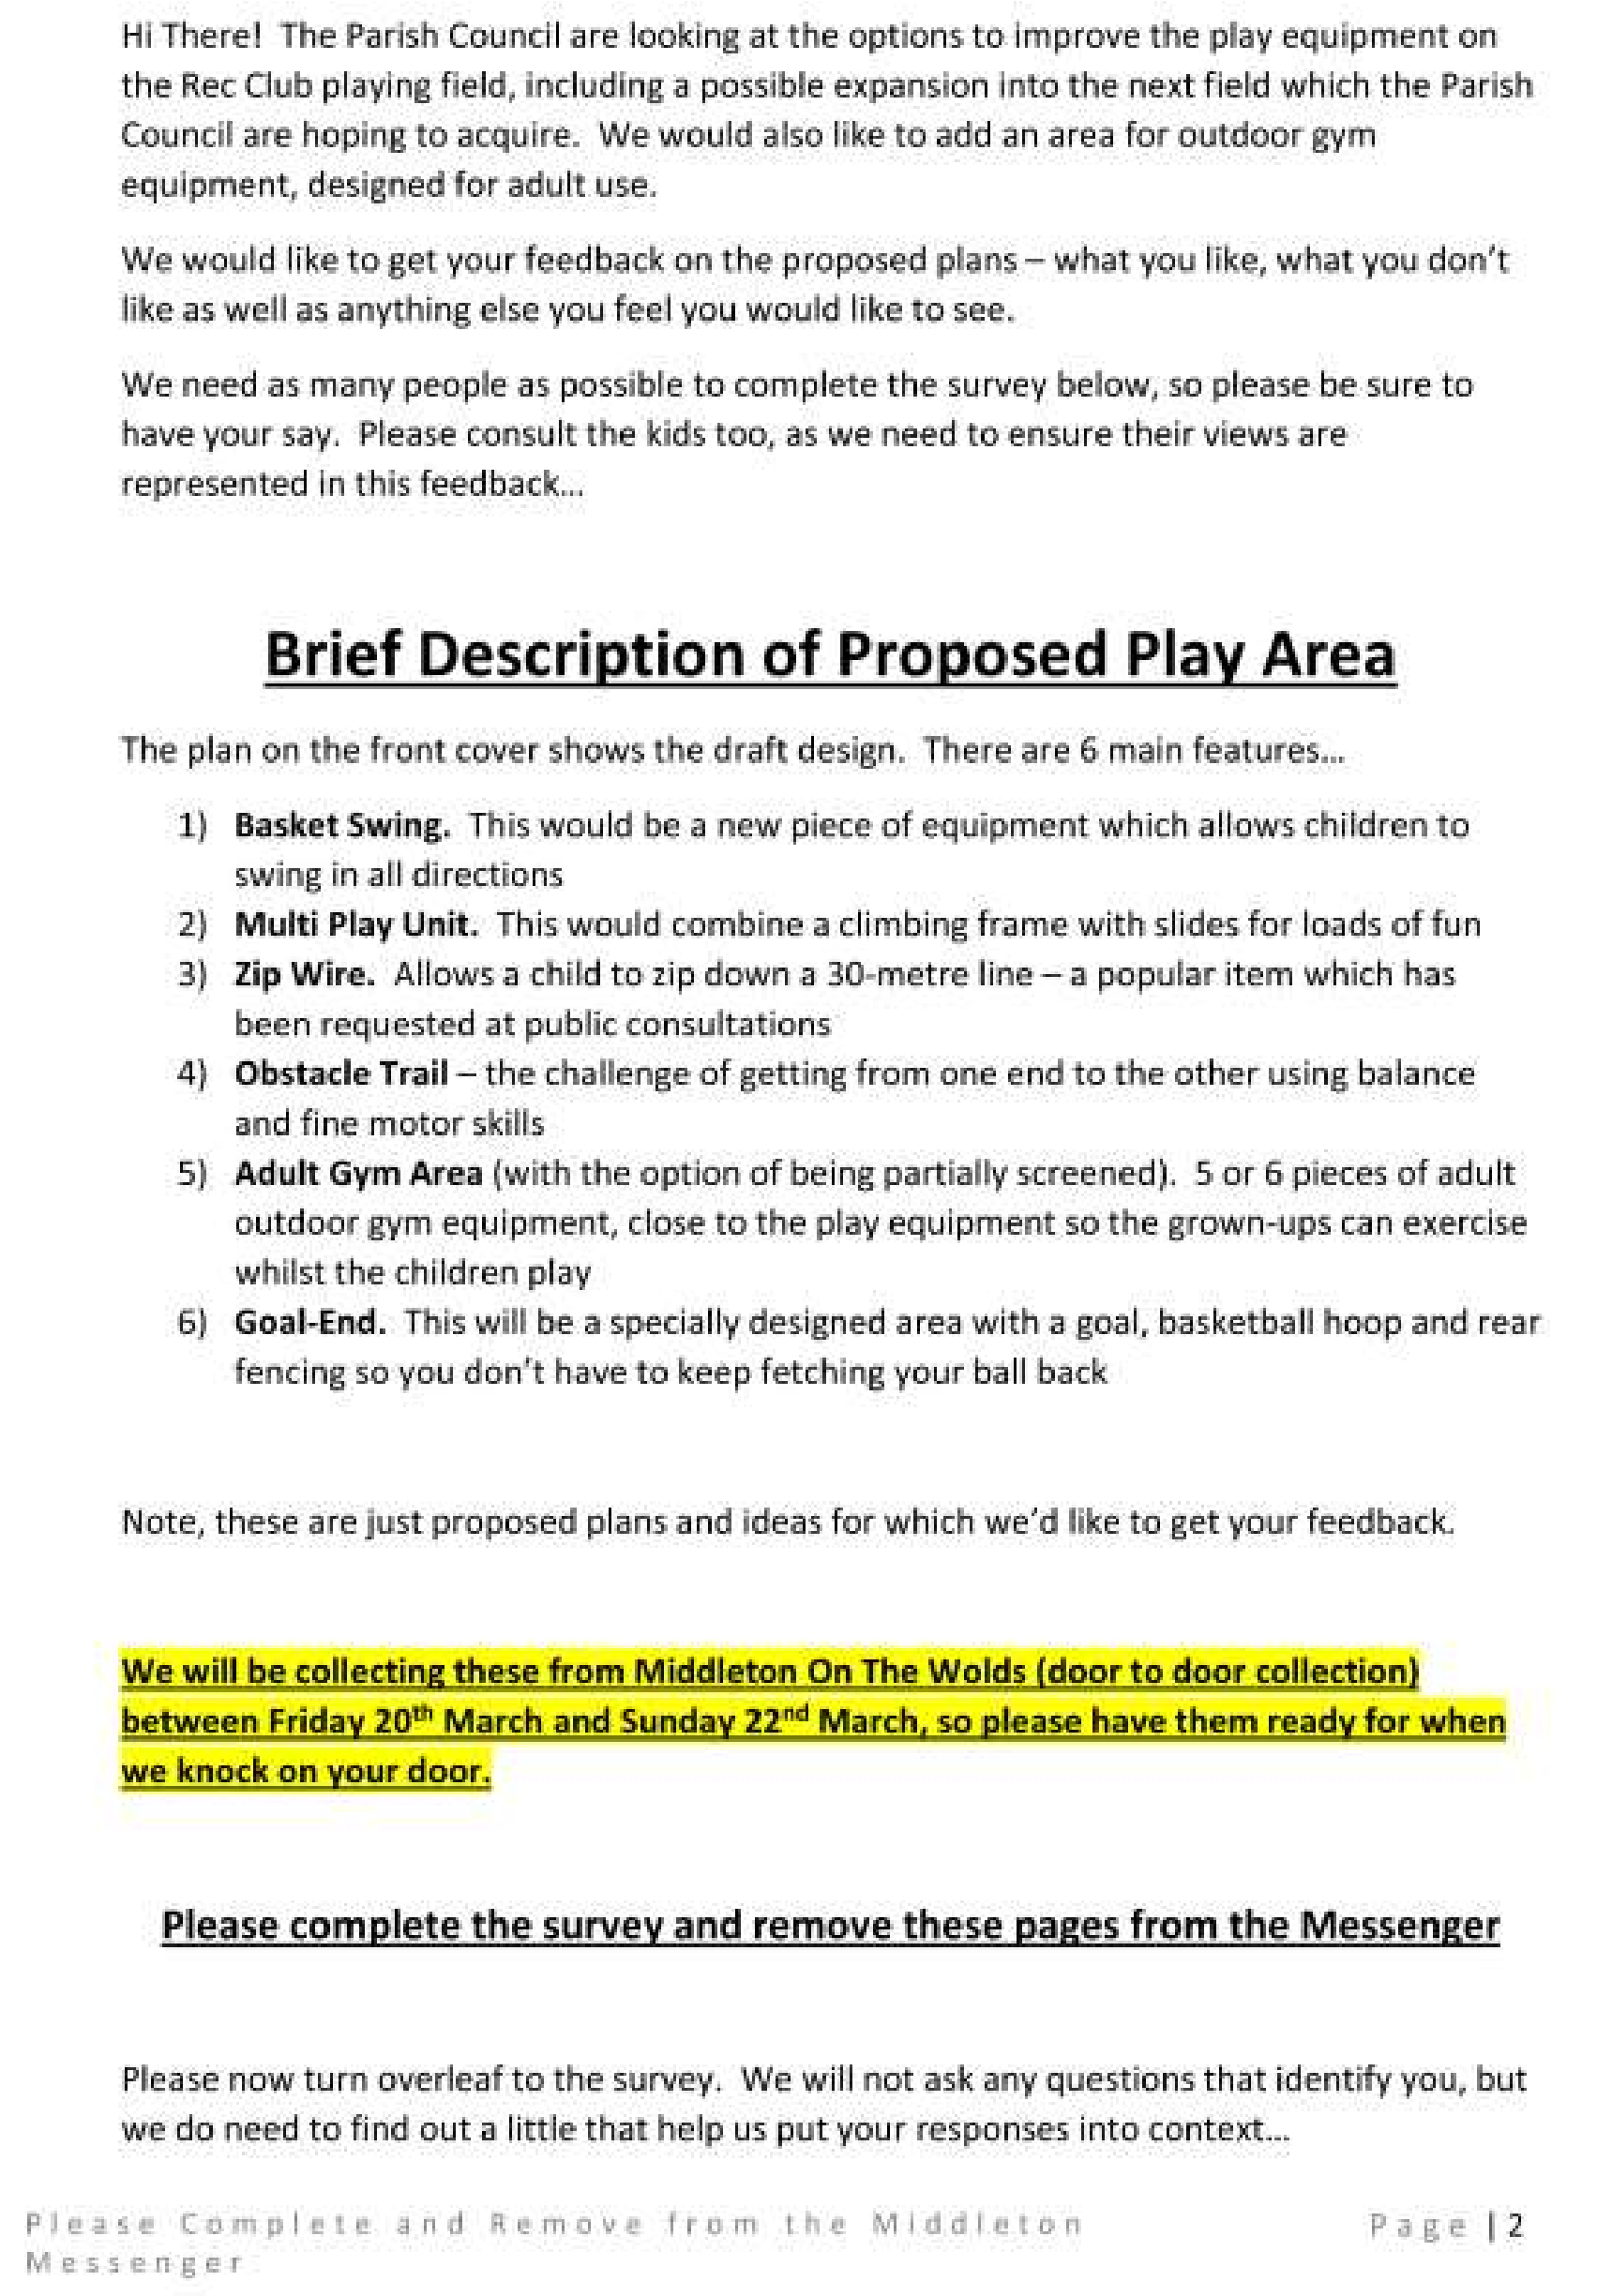

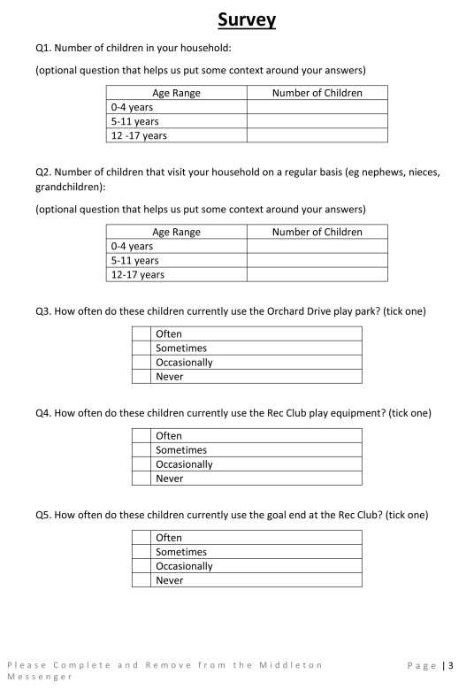

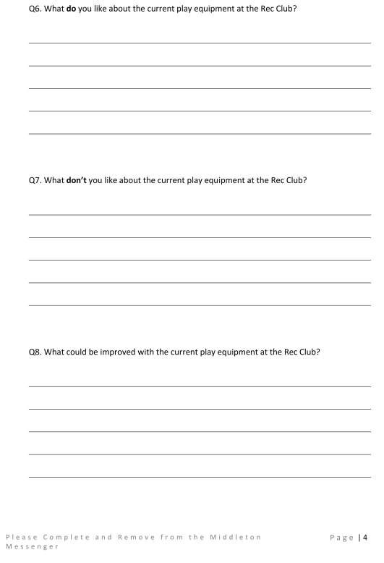

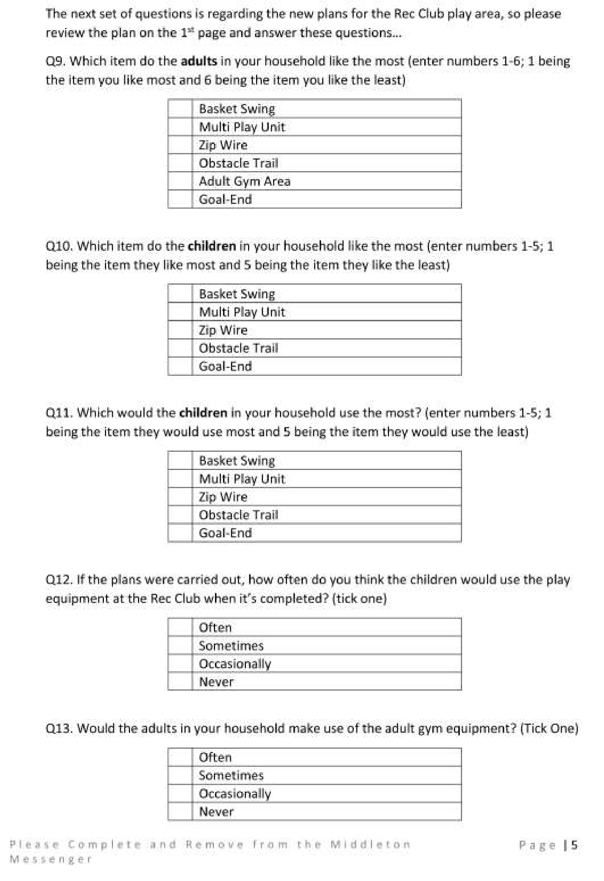

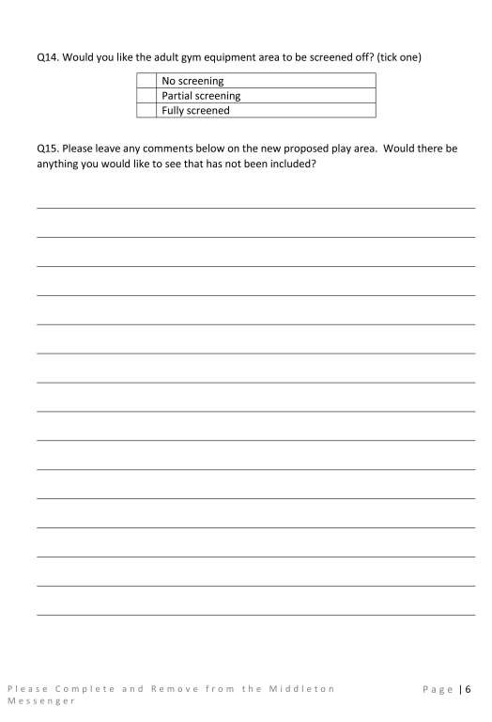

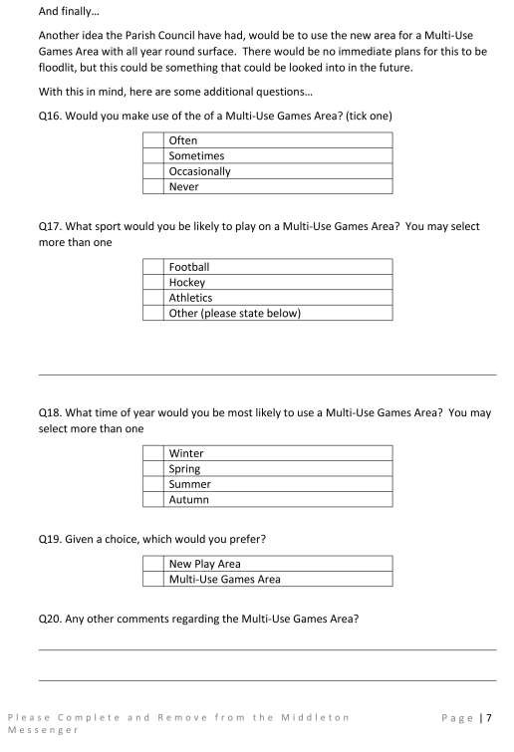

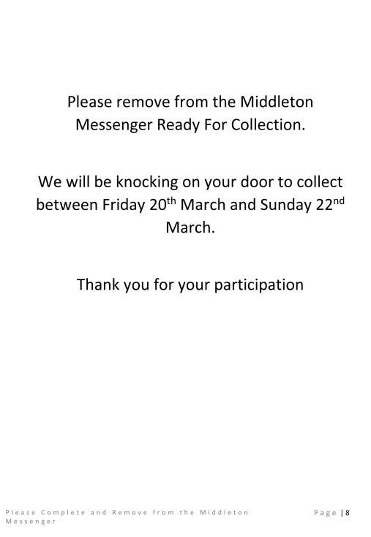

Middleton on the wolds ce ve school
Executive Headteacher: Mrs E Harros
Station Road, Middleton on the Wolds, Driffield YO25 9UQ
E-mail:middleton.primary@eastriding.gov.uk Tel: 01377 217323

London Residential
On Friday 7th & Saturday 8th February, 12 members of staff/adult helpers took a group of 52 children to London. An amazing time was had by all. Look out in next month’s newsletter for further information and photographs.

Middleton Minis
Our parent, carer, baby and toddler group runs from 1:30 to 3:30pm every Tuesday afternoon (term time only) at Middleton on the Wolds primary school. Drop in for 20 minutes or the full 2 hours. We look forward to seeing you.

On-going Collections
On-going Collections – We collect used stamps, batteries, printer cartridges and mobile phones. Thank you.

Middleton on the Wolds Nursery
At Middleton on the Wolds CE (VC) Primary School
→ Providing education for 2, 3 and 4 year olds Monday - Friday.
→ We accept the Government’s childcare vouchers for up to 30 hours of free provision for 3 year olds (conditions apply)
→ Additional sessions can be purchased for £13.50 per session for 3 year olds and £15.75 for 2 year olds.
→ Lunchtime sessions are £1.75 (free if children attend for the whole day) with the option to purchase a school meal for £2.40.
→ Children are welcome in the term after their 3rd birthday for funded places.
For further details, please contact: Heather Measom or Sharon Stone
Email: middleton.primary@eastriding.gov.uk Tel: 01377 217323
YorkShire countrYwomen’S ASSociAtion
A Musical Evening with
“The Farmers’ Daughters”
Friday 6th March
7.30pm
Middleton on the Wolds Village Hall
Tickets £5 including a glass of wine and nibbles
Proceeds split between Yorkshire Air Ambulance
and our YCA Club

For tickets and further information please contact
Linda Jones 01377 217512
Christine Johnson 01377 217374
Tickets are also available from
Wolds Waves and The Post Office

The
next
regular
meeting
of
the
Yorkshire
Countrywomen
’
s Association will be on Thursday 19th
March when Lesley Anne Greene will be talking about
Ceramic Sculpture.

Messenger correspondence
Hello Mike

I wish once again to raise the issue of the dreadful state of the footpath along Beverley Road.

In November 2017 following a site meeting with the East
Riding Council they refused to move the 30mph speed sign to the village boundary sign and would not consider a 40mph buffer zone either stating people drive at what speed they wish along country roads and would ignore the speed signs!!! The footpath was examined by the gentleman from the Highways Department and he agreed that remedial work was required especially where the two sinks are situated as these overflow and the result is mud and silt on the path. No work has been completed. I also asked for the footpath to be extended from the two cottages to the driveway of No.8 as we have to walk on the road immediately when the grass verge is boggy and muddy.

Since moving to live at No.8 the volume and speed of traffic using Beverley Road has increased significantly. During the winter months we are forced to walk on the road when walking into the village and this is a real risk when it is dark. We have torches but the cars seem to be oblivious to us and we feel extremely vulnerable and when there are two cars passing each other there is nowhere for pedestrians on the road.

We do realise there are not many residents living on Beverley Road but we feel we should feel safe and secure when walking into the village and would respectfully request you look into this situation for us and at least consider extending the footpath to our driveway and improving the footpath where the two sinks are situated

Thank you for your assistance in this matter.

Pam Spencer
8 Beverley Road
Hi Pam,
I appreciate your frustration at the lack of action over this problem. Apart from the section between the cottages and you the state of the area around the drain is truly shocking and it is right that you bring everyone’s attention to it. However, the Messenger can’t do anything about it. I have tried to make clear in previous editions that the newsletter and the Parish Council are different bodies and, although I am both editor and a Parish Councillor the two roles are quite separate. It would therefore suggest that you keep putting pressure on the County and Parish Councils directly to try to get some kind of resolution.
Sorry I can’t be of more help. Mike

Messenger correspondence
Hi Mike
I have started to clear the over grown path on the disused railway line leading to Bainton (behind the council road depot near to AB Graphics).
At my present rate I should be finished by the end of March, not bad with just a pair of shears.
I would like to see other dog walkers start to use the path as it would help to keep the weeds down, it's traffic and mud free but not suitable for toddlers, push chairs or flip flops!
Attached are the before and after photos to date.
Regards
Jim Wales
 | 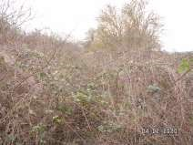 | 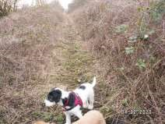
Hi Jim,
Great work – especially with just a pair of shears! I’m sure the rest of the village (not just the dog walkers, I hope) appreciate what you’ve done so far and, maybe, have a little go themselves. It would be an asset to the village if we could get a circular path set up and if we can clear this side of the embankment far enough we might be able to link up to Kilnwick Lane and from there to the public footpath up to and across Beverley Road, along the top to Goodmanham Road over the Rec to the embankment and back to Station Road. Wouldn’t that make a decent stroll!
Keep up the good work,
Mike

Local Birds & wildlife
Well, Storm Ciara has gone, Storm Dennis will soon be with us, and the birds are still singing away as though Spring has definitely arrived. Skylarks were singing along Warter Road the other day, and although the dawn chorus hasn’t started, the lighter mornings mean the twitterings and cheepings start earlier every day.
In common with a lot of people I have seen fewer birds in our garden this winter, presumably because of the unnaturally mild weather, but this week I heard from Barry that further up Greenfield Road has been a lot busier:
“It has been fairly quiet until about three weeks ago – now it seems every time I look out into the garden at the feeders on both sides of our bungalow I see birds; chaffinches, greenfinches, goldfinches, lots of blue tits, great tits, coal tits, long-tailed tits and quite a few marsh tits. The greater spotted woodpecker is visiting more often too and the sparrowhawks have come back with a vengeance – we see them all the time creating havoc with the birds on the feeders. One day recently we saw three birds flash through the garden over the feeders all at the same moment; there was nearly a mid air collision – very dramatic!”
He also had a first-ever treecreeper on the trees next to the feeders, and we also saw one a couple of times on the embankment trees at the end of our garden; I wonder if they are getting flushed out of their usual haunts by the tree-cutting activity further along the embankment?
The Paddocks has struck gold again, with Hazel reporting three male and three female bullfinches all feeding together. And Valerie had a great experience when coming back to Middleton on the bus at Lockington at about 4.30, which was dusk then, and the driver stopped the bus so that the passengers could watch a large starling murmuration! We have a flock of about 20 starlings that try their hardest, but with the best will in the world they can’t make the impressive swirling shapes as seen on Winterwatch.
Lastly, this is not wildlife, but did you know that if you register on the NASA website you can receive an email telling you whenever the Space
Station will be visible from your house? Well, it’s easier to spot than tawny owls, once you know when to look for it!
Lesser Spotted Woodpecker
Please let me know all the interesting stuff happening
around Middleton:
Lavenderbarbara97@gmail.com or phone or text on 0777 192 7868
Barbara

Middleton book group
The books chosen for February were the Beekeeper of
Aleppo by Christy Lefteri and the Night Circus by Erin Morgensten. Both had been read by some members of the group so we were able to have a discussion of both.
The Beekeeper of Alleppo covered the journey of a Syrian couple from Aleppo to the UK when their home land was destroyed by war and the beehives where they and an uncle produced honey to earn a living were burnt down. Afra the wife is blinded by a bomb and they embarked on their journey through many countries.
The book was written beautifully by the author and group members found it moving, powerful and compassionate. A book that reminds us of the power of storytelling.
The Night Circus is a book very different to the other choice. The circus only opened at night as the Circus of Dreams and combines fantasy, with different tents containing clouds, some ice and its aficianados seem to be under a spell and call themselves the reveurs-the dreamers. with a romantic thread running through the story. It is a captivating novel that makes the real world seem fantastical and a fantasy world real. The group had a mixed opinion of this book but it introduces a new author to those who enjoy this genre of story.

Next books for discussion:
10th March “The Librarian” by Sally Vickers
“The Garden of Lost & Found” by Harriet Evans

At the present time there are 8 in the book group, mostly from Middleton but we also have members in North Dalton, Kirkburn and Driffield. A different member hosts the meeting each month and chooses the books. Following the short discussion on each book we have a cup of tea and a piece of cake and have a general sociable chat. New members would be very welcome.

If you would like to join us please contact: Lyn Dennis 219500 lyndennis456@gmail.com

LOCAL HISTORY
MIDDLETON AT WAR

The war came to be known as the “The Peoples’ War” with the distinction between the home and the fighting front becoming blurred particularly in the early days. The British Government by legislation and propaganda put a legal and moral duty on the people to fully engage in the struggle for national survival and as a result there was hardly a part of the country not associated with war activities many of which remained secret. For the young in particular the consequent influx of strangers often added a new and exciting dimension to village life. However Tom Soanes’s first diary reference to the army presence seems less than enthusiastic “Soldiers made a hole in granary” on the 18th September 1940 and his last in February 1944 “Soldiers broke down gate post and burnt gate, went into field.”
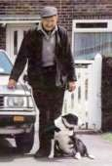
There was a REME (army) unit in the village with a NAAFI in Station Road later used as a school canteen. The Free French were also in the area. These were soldiers from France and her colonies together with Spaniards, particularly adept at guerrilla warfare, who had fled Spain after the civil war and who reached Britain to continue the fight against fascism after the fall of France. Jack Bentley remembered the Free French as being “grand fellows” and recalled football matches at Huggate after which they introduced the locals to the delights of baguettes and red wine. A less fortunate incident however took place when one of their number crashed an armoured vehicle into the brick wall on the sharp bend on Station Road near the present takeaway. Their brigade headquarters was Kilnwick Percy Hall
(Le Chateau) and Westwood House, North Dalton,
was also used. Doreen Munby (nee Soanes) saw General Leclerc take the salute of the Free French troops outside the garage in Front Street. In June 1944, as a face saving gesture, the general was allowed by the American Military to enter occupied Paris at the head of the liberation army. General De Gaulle leader of the French in Britain and future French President may also have visited North Dalton as he certainly went to Hull Guildhall where he was photographed with the Lord Mayor.
In recent years the existence of a “Secret Army” has become known. These were men with extensive local knowledge and firearms experience, facing certain death if caught, recruited with great secrecy by the authorities, with skill at poaching a useful extra qualification. By the feeble standards of the time they were well armed with such items as a revolver, dagger and a Mills bomb, their purpose was to
provide a last ditch opposition in the event of a German invasion. In Prickett’s Hollow wood there was an underground chamber with primitive living accommodation for use by local personnel and other such retreats were scattered throughout the East Riding. The Rose and Crown pub in Middleton was used as an unofficial meeting place and everything was “unofficial” in a phantom body of men that did not “exist” and who had signed the Official Secrets Act which legally prevented them from telling anyone, including their wives, the reason for their absence and possible disappearance. If however an invasion had happened their rearguard action would have met with savage reprisals from the enemy. Their story is told in local author Alan Williamson’s book “ East Yorkshire’s Secret Resistance”.
After the Japanese attack on Pearl Harbor in December 1941 and Hitler’s rash declaration of war on America there were eventually some two hundred US army personnel housed in huts in the Hall grounds near to the wall adjoining the cemetery and Hazel Brown recalled that they enjoyed very good supplies, even being able to show the latest films in the village hall. Hazel possessed a basic mess spoon belonging to an American soldier and often wondered what became of him. An unfortunate aspect of their stay however was the blatant discrimination shown against black personnel, the usual practice in the American forces at that period, which resulted in them spending a disproportionate time on guard duty and other menial tasks. Percy Dove, Hazel’s uncle, a veteran of the first war and landlord of the Rose and Crown was visited by the American colonel who asked him, none too politely, to exclude black soldiers from the pub. Mr Dove informed the colonel that he would decide who could visit his premises and told the colonel to absent himself. Tom Lazenby, a lifelong resident of North Dalton, recalls that the Free French showed similar disrespect for their North African comrades in spite of the supposed greater acceptance of black people in France.
Hazel’s independently minded grandmother sympathised with the black soldiers and invited some to tea with the result that she exhausted her own meagre supplies.
There were also German and Italian prisoners of war in the village. Here again Hazel’s grandmother was not averse to making toast for some of the Germans. Ordinary members of the Wehrmacht tended to behave themselves, no doubt preferring Middleton to the thought of the Russian front but it was different with the U boat crews who were often the more fanatical Nazi types whose activities had such a devastating effect on allied shipping and food supply. They were reluctant to do any work and maintained an aggressive attitude.
There were many social activities in the village during the war and new friendships formed. The Rose and Crown pub was used by younger people while the older ones preferred the Robin Hood. Women entered licensed premises more than in pre war days and much of the adult population smoked.

(TO BE CONTINUED)

Goeff Wisher
2 4 1 5 9 8 3 6 7  9 5 3 7 1 6 8 4 2  7 8 6 3 4 2 9 5 1  8 2 7 9 6 3 4 1 5  6 1 5 2 8 4 7 3 9  4 3 9 1 7 5 2 8 6  1 6 4 8 2 7 5 9 3  5 9 2 4 3 1 6 7 8  3 7 8 6 5 9 1 2 4 | Quiz answers  Where in  Middleton:  Bus stop by Village  Green  Primrose Cottage  Dingbats:  Frame of mind  Rough diamond  A large overdraught  Age before beauty  All in a day  ’  s work  An afterthought  1  Greenland  2  Hans Christian Andersen  3  Istanbul (Turkey)  4  1953  5  Parliament  6  Emergency Ward 10  7  David Frost first coined this  phrase in 'The Frost Programme'  8  Napoleon Bonaparte  9  Lung cancer  10  Franz Liszt

NEWS FROM OUTSIDE MIDDLETON
LUND VILLAGE HALL
Quiz Night, Lund Village Hall, Saturday 7th March.
All profits will go to BEAT, the eating disorder charity
Let's beat this together
Join us and raise funds between 2-8 March for Eating Disorders Awareness Week 2020
Doors open 19.00 for Quiz Start at 19.30
Cash only bar selling, beer, wines, soft drinks
Maximum 6 to a team
Table”nibbles” provided
Small prize for winning team,
Call 01377 217776 to book or enquire

……………………………………………………………………………………………………………………..

KEEP IT CASH - SAT 25TH APRIL 19.30 – LUND Village Hall
** BACK BY POPULAR DEMAND FOR A FAREWELL GIG! **
Keep it Cash are the UK's most accurate sounding tribute show to Johnny Cash. They have been touring & recording throughout the UK & the wider world for 20 years, have performed & recorded as the sound of Johnny Cash for International companies including 20th Century Fox, BT, Coca Cola & were chosen to perform at the launch of the Film “Walk the Line” in 2006.
This year in May 2020 the band have decided to retire, & they are delighted to come back to Lund for their penultimate EVER performance! Last time they visited us they received rave reviews.
-------------
Tickets SELLING NOW £12.50 adults / £6 under 16s - Licenced Bar
Jo Johnston on 07538 336259 or joannajohnston100@gmail.com
Or Leanne Barrett on 07885 980260 or lea.barrett@outlook.com
Advertisement

Advertisement

Advertisement

Advertisement

Advertisement

Regular group activities

Weekly Groups
Monday Coffee Morning 10.00am Reading Rooms
(Except when there is a Village Lunch - see below)
Monday Pilates 6.00-7.00pm Village Hall Tuesday Table Tennis 6.00-7.30pm Village Hall Wednesday Line Dancing 7.30-9.00pm Village Hall Thursday Middleton Movers 2.00-3.30pm Village Hall Thursday Pilates 7.00-8.00pm Village Hall

March
2 Village Lunch 12.15pm Robin Hood Inn
2 Parish Council 7.00pm Reading Rooms
4 Bell Ringing 7.30pm St Andrew’s Church
10 Book Group 2.00pm Kirkburn
10 Village Hall Committee 7.30pm Village Hall
- Bell Ringing 7.30pm St Andrew’s Church
- Country Women’s 7.30pm Reading Rooms 21 Charity Coffee Morning 10.00am Reading Rooms
22 Middleton Womblers 10.00am Lime View
LOCAL CONTACTS Bell Ringing Chris Atkin |  | 217285
Book Group/Middleton Movers | Lyn Dennis | 219500
Bowls Club | Rob Bradley | 217435
Country Women’s Association | Christine Johnson | 217374
First Responders | Chris Brent | 219469
Line Dancing | Pat Pottage | 217516
Methodist Chapel | Miss P Hodgson | 217426
Middleton Messenger | Mike Kelly | 07713 620912
 | Lyn Dennis | 219500
Middleton Womblers | Andrew Naylor | 219072
Parish Clerk | Sandra Morrison | 01262 470496
Reading Rooms | Kath Bentley | 217456
Recreation Club | Dave Newlove | 07901 833784
St Andrew’s Church | Rev Jane Anderson | 219471
St Andrew’s Church Warden | Roger Lowe | 217656
Table Tennis | Louise Newlove | 217801
Village Hall | Lyn Dennis | 219500
Village History Geoff Wisher |  | 217517

